**Oracle Installation Steps for Local Setup:**

1. Download Oracle from the URL provided: <https://www.oracle.com/database/technologies/xe18c-downloads.html>
2. After downloading, navigate to the installation folder and double-click on the setup.exe file located in the Oracle installation folder.



1. Proceed by clicking "Next."

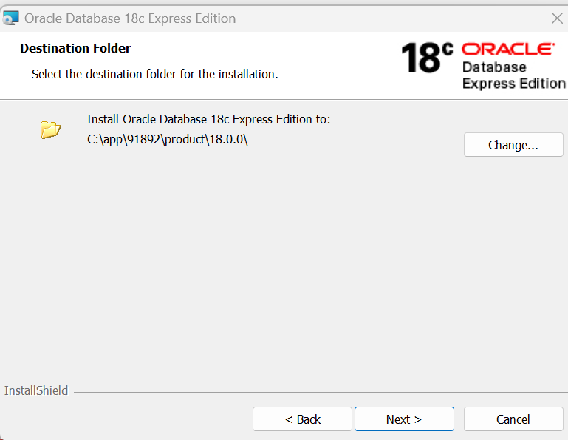

1. Continue by clicking "Next."



1. Enter the desired database password.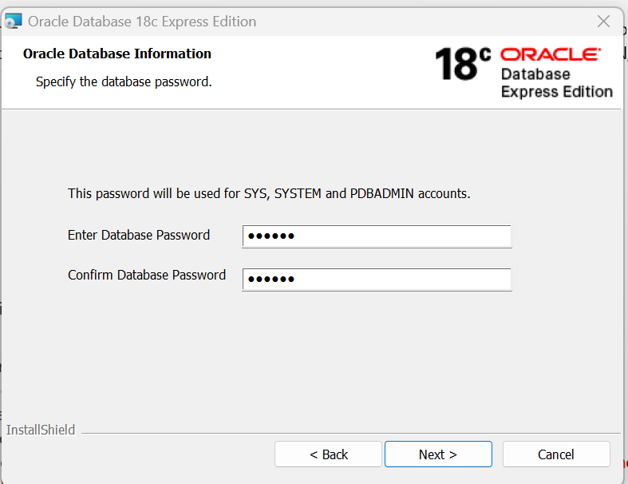
2. Click "Install" to initiate the installation process on the local system.

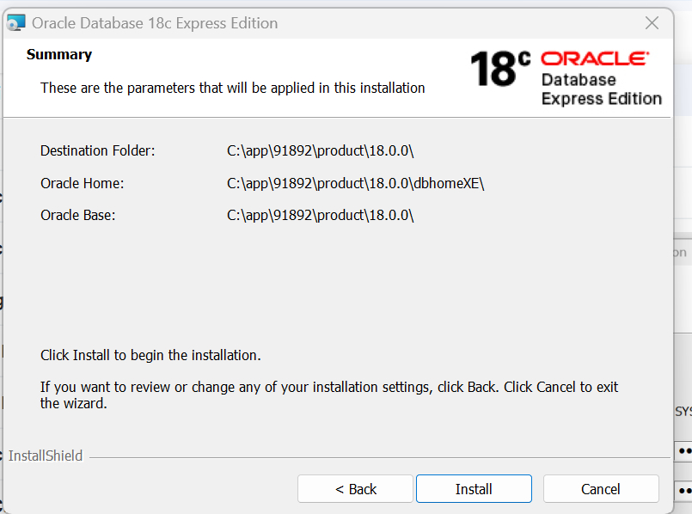

1. During installation, the screen will display the following message:

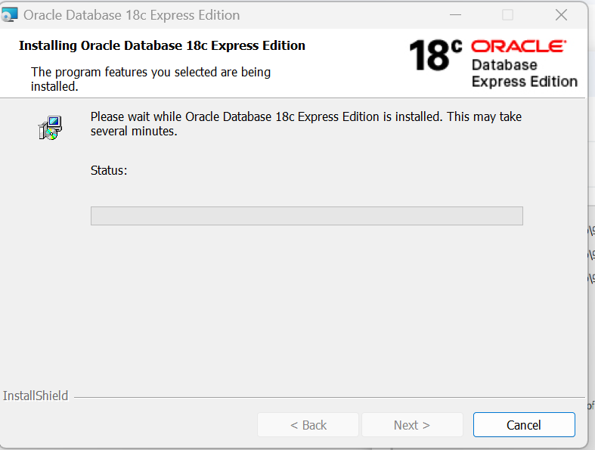

**Install SQL Oracle Developer as GUI tool for Oracle.**

1. To install Oracle SQL Developer, visit the following URL: <https://www.oracle.com/database/sqldeveloper/technologies/download/>
2. Once downloaded, navigate to the folder, and double-click on sqldeveloper.exe to launch the application.  
   A screenshot of a software

   Description automatically generated

**Importing DUMP file into Oracle DB:**

1. Open the command prompt and execute the following command: **sqlplus / as sysdba**.
2. Run the following queries to create tablespaces:

create tablespace HW_INDX_SMAL_08K datafile 'C:\app\Dharanij\product\18.0.0\oradata\XE\HW_INDX_SMAL_08K_01.dbf' SIZE 25M REUSE AUTOEXTEND ON MAXSIZE UNLIMITED;  
create tablespace HW_TX_LOBS_16K datafile 'C:\app\Dharanij\product\18.0.0\oradata\XE\HW_TX_LOBS_16K.dbf' SIZE 25M REUSE AUTOEXTEND ON MAXSIZE UNLIMITED;  
create tablespace HINAI datafile 'C:\app\Dharanij\product\18.0.0\oradata\XE\HINAI.dbf' SIZE 25M REUSE AUTOEXTEND ON MAXSIZE UNLIMITED;  
create tablespace HW_BG_INDX_16K datafile 'C:\app\Dharanij\product\18.0.0\oradata\XE\HW_BG_INDX_16K.dbf' SIZE 25M REUSE AUTOEXTEND ON MAXSIZE UNLIMITED;  
create tablespace HW_TX_INDX_16K datafile 'C:\app\Dharanij\product\18.0.0\oradata\XE\HW_TX_INDX_16K.dbf' SIZE 25M REUSE AUTOEXTEND ON MAXSIZE UNLIMITED;  
create tablespace HW_TX_DATA_08K datafile 'C:\app\Dharanij\product\18.0.0\oradata\XE\HW_TX_DATA_08K.dbf' SIZE 25M REUSE AUTOEXTEND ON MAXSIZE UNLIMITED;  
create tablespace HW_DATA_JBPM_16K datafile 'C:\app\Dharanij\product\18.0.0\oradata\XE\HW_DATA_JBPM_16K.dbf' SIZE 25M REUSE AUTOEXTEND ON MAXSIZE UNLIMITED;  
create tablespace USERS datafile 'C:\app\Dharanij\product\18.0.0\oradata\XE\USERS.dbf' SIZE 25M REUSE AUTOEXTEND ON MAXSIZE UNLIMITED;  
create tablespace HW_INDX_BIGS_16K datafile 'C:\app\Dharanij\product\18.0.0\oradata\XE\HW_INDX_BIGS_16K.dbf' SIZE 25M REUSE AUTOEXTEND ON MAXSIZE UNLIMITED;  
create tablespace MIS datafile 'C:\app\Dharanij\product\18.0.0\oradata\XE\MIS.dbf' SIZE 25M REUSE AUTOEXTEND ON MAXSIZE UNLIMITED;  
create tablespace HW_TX_RPTS_08K datafile 'C:\app\Dharanij\product\18.0.0\oradata\XE\HW_TX_RPTS_08K.dbf' SIZE 25M REUSE AUTOEXTEND ON MAXSIZE UNLIMITED;  
create tablespace HW_INDX_BIGS_08K datafile 'C:\app\Dharanij\product\18.0.0\oradata\XE\HW_INDX_BIGS_08K.dbf' SIZE 25M REUSE AUTOEXTEND ON MAXSIZE UNLIMITED;  
create tablespace HW_INDX_MEDM_08K datafile 'C:\app\Dharanij\product\18.0.0\oradata\XE\HW_INDX_MEDM_08K.dbf' SIZE 25M REUSE AUTOEXTEND ON MAXSIZE UNLIMITED;  
create tablespace HW_DATA_RPTS_08K datafile 'C:\app\Dharanij\product\18.0.0\oradata\XE\HW_DATA_RPTS_08K.dbf' SIZE 25M REUSE AUTOEXTEND ON MAXSIZE UNLIMITED;  
create tablespace HW_DATA_ZTAB_08K datafile 'C:\app\Dharanij\product\18.0.0\oradata\XE\HW_DATA_ZTAB_08K.dbf' SIZE 25M REUSE AUTOEXTEND ON MAXSIZE UNLIMITED;  
create tablespace HW_DATA_LOBS_16K datafile 'C:\app\Dharanij\product\18.0.0\oradata\XE\HW_DATA_LOBS_16K.dbf' SIZE 25M REUSE AUTOEXTEND ON MAXSIZE UNLIMITED;  
create tablespace HW_TX_ZTAB_08K datafile 'C:\app\Dharanij\product\18.0.0\oradata\XE\HW_TX_ZTAB_08K.dbf' SIZE 25M REUSE AUTOEXTEND ON MAXSIZE UNLIMITED;  
create tablespace HW_DATA_ZTAB_16K datafile 'C:\app\Dharanij\product\18.0.0\oradata\XE\HW_DATA_ZTAB_16K.dbf' SIZE 25M REUSE AUTOEXTEND ON MAXSIZE UNLIMITED;  
create tablespace HW_DATA_BIGS_16K datafile 'C:\app\Dharanij\product\18.0.0\oradata\XE\HW_DATA_BIGS_16K.dbf' SIZE 25M REUSE AUTOEXTEND ON MAXSIZE UNLIMITED;  
create tablespace HW_TX_INDX_08K datafile 'C:\app\Dharanij\product\18.0.0\oradata\XE\HW_TX_INDX_08K.dbf' SIZE 25M REUSE AUTOEXTEND ON MAXSIZE UNLIMITED;  
create tablespace HW_TX_BACK_08K datafile 'C:\app\Dharanij\product\18.0.0\oradata\XE\HW_TX_BACK_08K.dbf' SIZE 25M REUSE AUTOEXTEND ON MAXSIZE UNLIMITED;  
create tablespace XXKIMS datafile 'C:\app\Dharanij\product\18.0.0\oradata\XE\XXKIMS.dbf' SIZE 25M REUSE AUTOEXTEND ON MAXSIZE UNLIMITED;  
create tablespace HW_DATA_SMAL_08K datafile 'C:\app\Dharanij\product\18.0.0\oradata\XE\HW_DATA_SMAL_08K.dbf' SIZE 25M REUSE AUTOEXTEND ON MAXSIZE UNLIMITED;  
create tablespace HW_DATA_MEDM_08K datafile 'C:\app\Dharanij\product\18.0.0\oradata\XE\HW_DATA_MEDM_08K.dbf' SIZE 25M REUSE AUTOEXTEND ON MAXSIZE UNLIMITED;  
create tablespace HW_DATA_BIGS_08K datafile 'C:\app\Dharanij\product\18.0.0\oradata\XE\HW_DATA_BIGS_08K.dbf' SIZE 25M REUSE AUTOEXTEND ON MAXSIZE UNLIMITED;

1. Execute the following SQL command in SQL Plus to create a user:  
   CREATE USER C##aehlive01 IDENTIFIED BY oracle; in sql plus
2. Exit SQL Plus using the **exit** command.
3. In the command prompt, execute the following command to import the DUMP file  
   impdp system/oracle dumpfile=aehlive01_010224.dmp logfile=imp.log remap_schema=aehlive01:C##aehlive01
4. Press Enter to start the import process.